How does your brain operate?  
Mental Operation

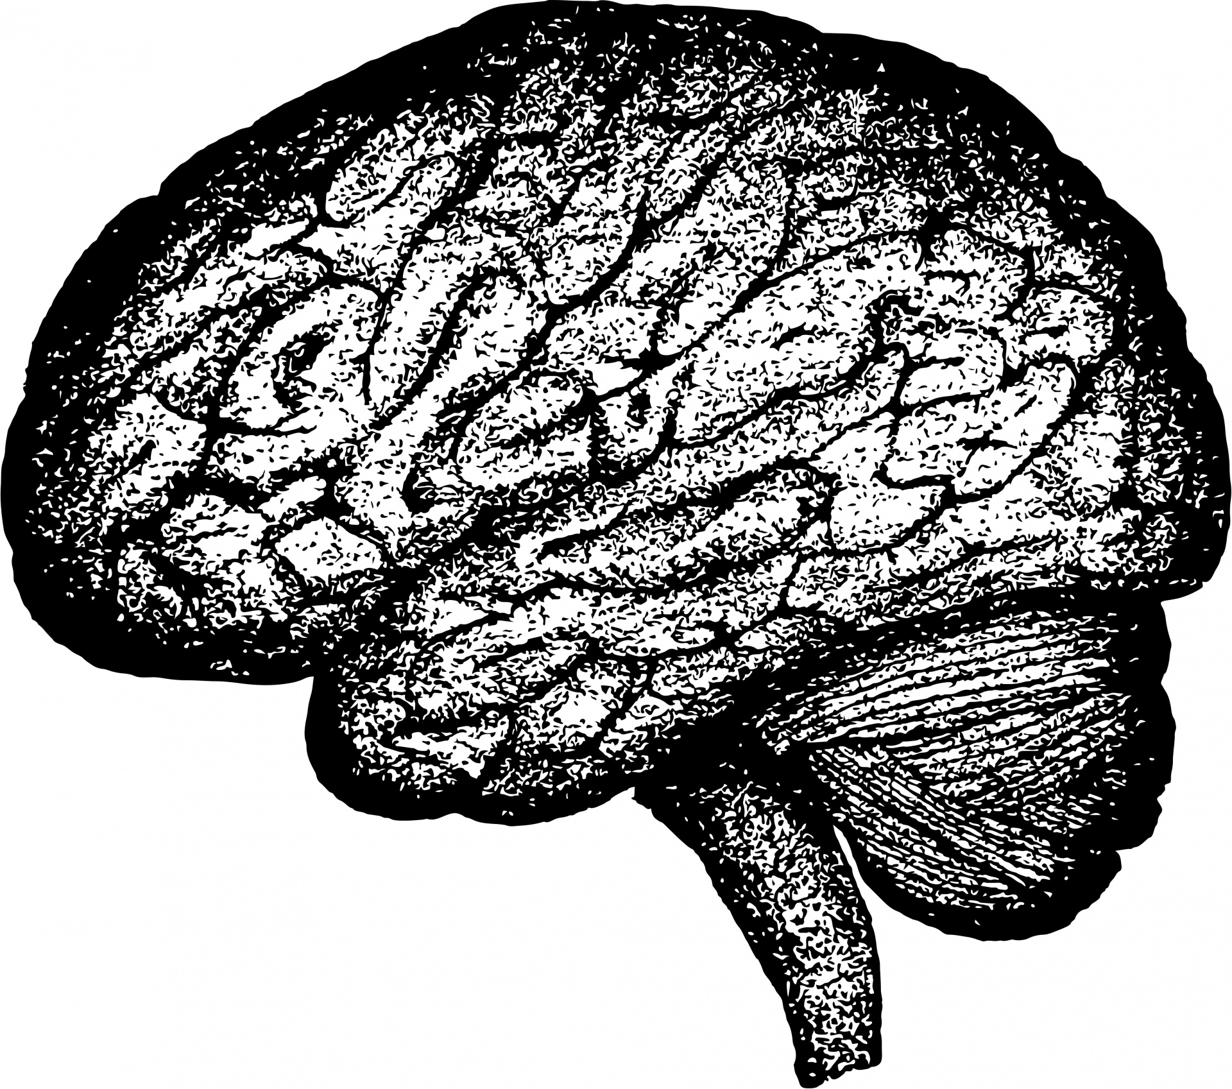

**___**

By: Essence M. Clark

# INTRODUCTION

The brain is a true display of explicit complex abstract art. A piece of us that we rarely shine a light on. Infrequent in conversation and overall controversial and swept under the rug. Mental health is often characterized effortlessly; within our communities, associations and families.

Mental illness is portrayed as this set of dynamics that are often bare and adverse when it comes to the real underlying drawback of mental health in our modern society. Believe it or not there is a great amount of individuals who believe they are living completely normal day to day lives; where in reality nothing about it is normal. A lot of us have underlying mental issues that we have little information about or they are just completely ignorant to the entire topic.

I believe it is critical that we make mental health a well-observed prioritized conversation in our communities and families. Living life ignorant to the effect and causes of our favorable and traumatic experiences leaves us vulnerable to nonconsecutive inconsistencies and adaptation of abnormal behaviors in our lives and in our families. Something as little as just being more aware of ourselves and our actions, knowing where they come from and how they have come to exist can play a huge role in our recovery as a whole.

So, where should a person who is concerned with obtaining further enlightenment on this particular topic begin?

Well one could start by asking themselves this…,”Am I a dominant person?” or, “Am I a submissive person?”. Say you were at home relaxing and unbothered. Your spouse enters the room and displays some unwanted “Spiritual animosity” towards you; as I like to call it and you absolutely have no idea why. Are you more likely to demand that your partner clarify their reasoning? Or, are you more likely to introduce your own form of animosity, without clarity of the cause to your spouse's hostile reaction?

Be honest with yourself. That is the only way to obtain thorough comprehension and authenticity of your unique psyche. Let’s begin!

Leaning Towards Truth

As I advance through my own life I have taken in the knowledge to believe that I can be both, submissive and dominant. So, if I had to identify which one I am the most; I would say I am very much more submissive. The reason I believe this is because I am much more likely to abandon a confrontation with a less amount of cognitive skills.

I came up with this interpretation because I made a commitment to myself to let go of all denials that I am aware of and forever after. When I truly accomplished this commitment to myself, I found it much easier to perceive myself from an envisioned outside perspective. I quickly realized that this is something that a person has to ‘Want’ in order to achieve accurate results. It takes effort and some sort of soul searching and the capability to just downright be honest with yourself.

### Who Are You?

No doubt, this is one of the hardest questions anyone could ask you, or that you could ask yourself. It’s a question that can almost instantly spark anxiety, in even the most established of people. But, when you actually put some conscientious thought into it you’ll realize that most of us are working towards accomplishing our most visualized desired roles in life. By the time we reach mid-adolescents we begin to learn how to maintain that image. In fact, this whole concept begins when you're just an infant.

As we get older and our personality begins to form we generally establish a set of characteristics through critical cognitive observation of our surroundings; our parents, school, friends, family members and even complete strangers we encounter along the way. When it comes to your individual personality; most people can almost instantly think back and remember something that took place, something or someone; either a role model or even a less tasteful person that can account for their current characteristic or trait that they now carry with them.

Honesty Will Set You Free!

#### 

It’s safe to say that no one likes to be criticized or judged but let’s face it, if we can’t be honest with ourselves; how will we ever be able to accept constructive criticism? How will we be able to obtain useful advice and critique in our everyday lives? Do we want something this inconspicuous to be the reasoning for our upcoming trials and tribulations?

It took me a long while to be honest with myself and comprehend the fact that some people just downright discern themselves with the truth and reality and just completely run from it. Individuals who work hard to stay in a state of denial is my reason for why mental health is a sparsely talked about conversation today. In my opinion, I believe these kinds of people want to disguise their health issues and act like trauma doesn't scar you mentally; or even exist for that matter.

Many people do not realize that there could be a cause for the reason they don't allow themselves to do certain things or, a reason we have subjects or topics that can seem ‘touchy’ to us. Some of us have way too much confidence in the way our brains operate. I know this because I once had this same trust in my own brain.

**Drama or Trauma?**

Have you ever witnessed someone having what seemed like a mid-life crisis? Have you seen someone overthink their way into complete chaos. Well, if you have then you most likely expressed either complete genuine sympathy or exhibited an act of insensitivity and thoughtlessness. It took me to have to endure my own form of crisis to fully understand where and what these traits come from and what they begin to stem from.

I would like to lay the foundation of how I perceive traumatic experiences. By the time you reach adulthood most individuals have encountered numerous traumatic experiences throughout adolescents. Have you ever been in a car accident?

Have you ever embarrassed yourself in a crowd of people? Or, did you receive verbal and physical punishment as a child? If you answered yes to any of these questions almost more than positively you have come face to face with a traumatic experience.

These experiences, when left unresolved with built-up internalized emotion can produce characteristics and traits that we either let go unnoticed or we do notice, while we continue to maintain a state of denial that these features primarily exist. Many people do not realize that maintaining these aspects of denial can play a big negating role within your mannerism.

**Personality Vs. Internal Damage**

Have you ever encountered a stranger who seemed just as cold as Christmas day, all the time; usually a elderly person? One thing I almost immediately recognized about this interpretation is being the person viewing this individual on the outside, either developing one of the two previously talked about feelings: Empathy or Sympathy has almost instantly a unique interpretation of others.

More than often I tend to be a more sympathetic person because I understand the dynamics of both personality and internal damage. You have to ask yourself, “is this person just built that way? Are they actually a nice person underneath the frown?(Personality) Or, did something happen to them that constructed them to now forever be this way.(Internal Damage)

I have accepted the fact that some people probably don't ask themselves these questions at all. In most cases they probably have zero alertness when it comes to the welfare of others or the human race all together for that matter. But, for those who display empathetic behaviours have some type of recollection of trauma in their own life that are most likely still very sensitive to them. The overall conclusion most people come up with is that there is an answer that will remain inexplicable about the strangers characteristic.

In fact, most individuals have come across some form of trauma within their journey through life, knowing this allows yourself to potentially gain sympathy for another person or individual.

**Capable of Caring**

When you see your spouse or family member crying and distraught, do you back off because “You don't know what to do”, or do you embrace them with unconditional uplifting support.

A great number of men would agree to the first statement, while i'm not iterating that all men are insensitive but more so something else. A Lot of men don't realize that something has damaged them emotionally or even worse they’ve never displayed genuine emotion at all stemming from a particular circumstance or no circumstance at all. The overall point is to be able to know exactly which category you fit in; knowing this is the perfect beginning to a tremendous recovery.

For those who have trouble with this particular issue; unable to sympathize with others and maintain a genuine feeling about people. Beginning to come out of denial about these issues can cause what are known as a ‘Trigger’. Triggers can be either a person, place, thing, event or circumstance that is the cause of a distinct action, process, or situation. When someone becomes triggered, the sympathetic division of our nervous system is affected. Imagine this division as if it were an accelerator pedal; it can also be compared to a timer or an hourglass. Once this trigger has registered through the nervous system and stimulated the adrenal gland the ‘Fight-or-Flight' response is initiated.

An important thing one must understand is that always picking the flight mode doesn’t necessarily mean that you or, that person doesn’t care. Actually this is a sign, almost always perceived as an act of submissiveness and or intimidation. We as humans need to brief ourselves on the fact that avoiding resolutions, conclusions or closures only empowers the triggers, and leave what I like to call “cognitive bruising”.I obtained this knowledge for myself during the start to my recovery.

**Fix it or Leave It**

On the occasion one will encounter a perception of a trigger which could potentially lead to an either stressful or frightening event, is enough to activate the ‘fight-or-flight’ response.

Once the nervous system has fully distinguished this supposed threat, the hormones that release into the body begin to alter your heart rate, directing or diverting blood flow, and many other related nervous functions that affect the bodies sudden increase in energy and strength.

After our nervous system surrenders to all these intrusions; we begin to show our true colors. If this trigger is something someone is avoiding they are more likely to be submissive to it in a sense, whereas if they are more liable to overcome it or downright abolish it; that person is overall more dominant towards that specific trigger. This why my preeminent rationale for beginning this specific conversation with…”Are you more dominant or submissive?” with my peers. A bulk amount of people actually never really come out of denial and focus on their overall majority responses to their underlying triggers.

**Proper Evaluation**

I prefer to classify Mental Health as simply the product of all the hardships that have intruded, disrupted and disturbed our minds, spirits and our individual inner-peace. Being honest with yourself and allowing your mind to be free of denial is a whole form of meditation within itself; but working towards this point will allow you to perceive an suitable self-diagnosis and evaluation of your own mental health position.

Not knowing this significant information about yourself is one of the leading causes of why so many Americans are oblivious to the fact that they are living with a diagnosable mental illness. While enduring, and attempting to tolerate said illnesses and almost always left vulnerable to suffer at the hands of a tentative trigger. But what about those out there who believe that nothing is wrong with them, “It can’t be true”, and or “It must be others who are the ones disabling themselves with unknown long-term illnesses, not me?” which I can relate to because when I was once in denial about my excessive anxiety and mood swings captivating me. I lead myself down a dark path of loneliness and depression.

As I continued to unknowingly suffer from my illness, I didn’t realize I was giving it additional room to manifest.Ultimately leaving me at risk of provocation and unpredictable and erratic panic attacks, or anxiety attacks.

Well if you're not quite buying it yet or you're just nervous about what you could discover(Anxiety) from getting a quick mental assessment. I want to encourage you to go out on a limp and presume that this matter at hand is important and can do more good than harm. I also want to persuade you to take a peak! I challenge you to begin your own further analysis of your past and your current actions, reactions and behaviours. I assure you that the vital enlightenment on the origins of your actions and will be one of the most inquisitive assets you’ll ever grasp onto.

**Start New Beginnings**

I reiterate that living life without proper analysis of your mental state can lead to unnecessary suffering. Even leaving certain issues unresolved can be risky since traumatic situations and events can leave us vulnerable to introducing new characteristics and behaviours without consciously registering it. Without closure of certain said events can lead to the creation of triggers. Beginning to learn these new things about yourself can definitely get overwhelming and can potentially become a trigger in itself but learning how to establish this relationship with your mind is imperative to the preservation of the human brain.

**Talk To A Professional**

A lot of people get anxiety when someone even mentions the thought of a mental health physician or psychiatrist. Anxiety is a diagnosable mental illness but it's also a normal feeling that occurs when one has a feeling of nervousness, unease and sometimes excessive worry about an imminent uncertain outcome. One can literally be nervous of the future or, of change. Once I explained my feelings to a professional which at the time, I didn't fully understand how those fatuations were fearful and compulsive behaviours and traits which I was oblivious to. I obtained significant aid and assistance with my everyday life through just taking out the time to cater to my mind.

You know the saying people proclaim, “If it’s not broken, don’t fix it” well how can you know if something is broken or not if you don't get an inspection. I hope this encourages others to be more mindful and give more consideration to our brains.

**About Author**

Hello, everyone my name is Essence and I was diagnosed with PTSD and GAD, which stands for Generalized Anxiety Disorder. Although I have this illness it does not define me or control me anymore. I had no recollection of my childhood and adolescent experiences; which were traumatic, and were the primary cause for me developing this illness over the years. Now that I have formed this bond with myself and committed my effort to the welfare of my mental state, Life has become very achievable and I can deal with certain stressors in a thought out method. Having the ability to see things in a clearer and calmer perspective is more than refreshing. On the downside I often notice a large amount of my peers who are out of touch with their mental state.

Considering the fact that I am a more empathetic and selfless kind of person it worries me of what the future of mankind could potentially come to. If people stay in denial about their mental wellness, spirit and soul how could we possibly be in touch with reality. Will we ever be able to fully progress in the future?

Thank you so much for taking the time to indulge in my spec article. I love to write and review exceptional pieces of prudence and unconditional consideration for literature. One day I would love to be a Journalist and author, anyone who supports me is the most dearest to my spirit. Writing will forever be my most cherished outlet.

“Let go of the attachment, keep the lesson.” -L.J. Vanier-(**Themindsjournal.com**)